**Promoted for and on behalf of Cycling Tim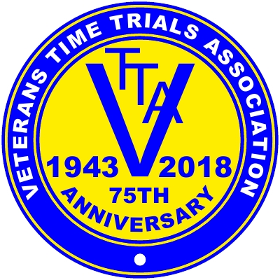e Trials under its rules and regulations**

**The RESULTS SHEET for the**

#### East Anglia VTTA 10 mile Individual Time Trial

**COURSE F2/A10 – SATURDAY 17th August 2024**

**AWARDS.**

**Fastest Male on AAT.**

**Keith Dorling Team Bottrill 18.06 £50**

**Anthony Turner Mickey Cranks C.C. 18.24 £40**

**Roger Porter Verulam C.C. 18.25 £30**

**Eddie Humphreys Nottingham Clarion C.C. 18.56 £20**

**Matt O’Brien, Robert Watson, Martin Reynolds, Nic Pillinger - all £10 each.**

**Fastest Female on AAT.**

**Mary Twitchett Cambridge C.C. 18.30 £50**

**Hannah O’Brien Loose Cannon’s Conditioning 18.56 £40**

**Team of 3 Men on AAT. Cambridge C.C. (R.Watson, M.Reynolds, A.Fisher) 58.33 £20 each**

**No Women’s Team completed.**

**Best East Anglian Vet on AAT. Ron Fisher / Jack King Memorial Shield - Keith Dorling.**

**Prize winners will need to e-mail me their bank details asap for prizes to be paid. Winners opting for a VTTA medal in lieu will also need to notify me. Prizes not claimed within a month will be donated to the Isabel Hospice.**

**My thanks go to the following people.**

**Keith West - for the start and results sheets and the results board on the day (plus countless other bits of advice) and Tim and Wally Groves for Timekeeping.**

**Andy Bright, Adrian Gower, Norman King and Mark Arnold did the marshalling.**

**Matt O’Brien helped with pushing off and Hannah O’Brien texted times back to HQ- both after having ridden in a combined husband and wife total of just 40.46! (Is that a record?)**

**Dave Nock ran signing on/off and Keith Dorling did the signage (before and after the race)**

**Renee Friend and her team did catering duties as a fund raiser for the Isabel Hospice (to whom several riders and marshals have also donated their prizes and expenses.**

**And finally, thanks to Lisa at Hardwick Sports and Social Club.**

**I could not run this event without this brilliant team.**